Sudhakar Chintamalla

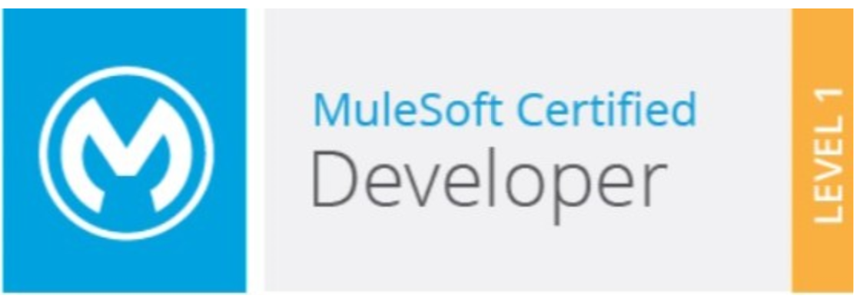 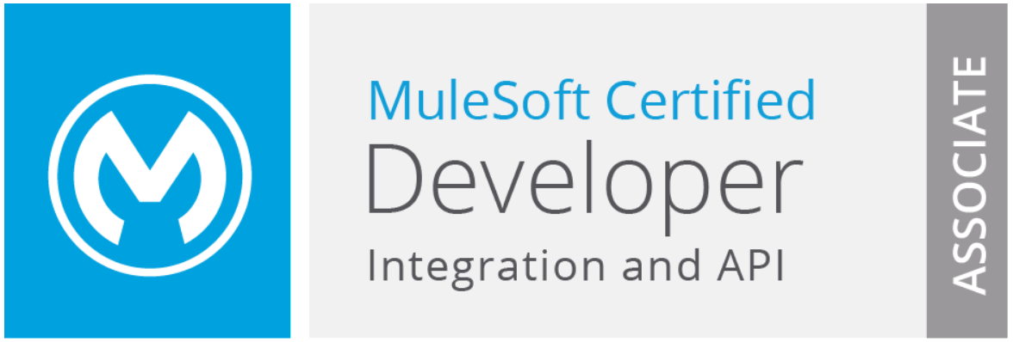

+1 2142998373 | [rishitha.23g@gmail.com](mailto:rishitha.23g@gmail.com) | [linkedin.com/in/sudhakar-chintamalla-34a0b3125](https://www.linkedin.com/in/sudhakar-chintamalla-34a0b3125)

# Summary

* Overall **16+ years** of IT experience with **6.5+ years** of **MuleSoft** and **9+ years** of **PeopleSoft** in various application phases of Software Development Life Cycle including Designing, Development, Testing and Production Support.
* Experienced in leading the Architecture, Design and Development of Enterprise Integration solutions using API-led connectivity, Microservices architecture and Batch Integrations.
* Expertise in Service Oriented Architecture(SOA), External Authorization Broker (EAB), Enterprise Application Integration(EAI).
* Experience in **Waterfall, Agile & Scrum** development methodologies.
* Experience in **Mule ESB, API Management, Continuous Integration and Continuous Delivery, Deployment** [**4.x, 3.9.7 & 3.8.5**].
* Expertise in using Anypoint studio in creating various flows to integrate **API's, Databases, and other applications.**
* Good experience in using Mule Connectors such as **HTTP/HTTPS, File, FTP/sFTP, LDAP, Data Weaves, Database, Choice Router,** Salesforce Connector (operations, limits, etc), Encryption/Decryption, **Scatter Gather** and **Batch Processing**.
* Have an extensive experience in using **Data Mapper** and **Data Weave** for transformations.
* Hands on experience designing RAML specifications, building APIs using API Kit in Mule applications.
* Have implemented an API using Swagger in MuleSoft and worked on **OAS 3.0 YAML** as the format for the API specification.
* Defined API endpoints, request, and response using YAML
* Configured API’s to deploy to the run time fabric(RTF) and cloud-hub environment.
* Design and provided technical solutions to the API’s to deploy to run time fabric(RTF) and cloud-hub environment.
* Designed and implemented OAuth 2.0 authentication and authorization mechanism in MuleSoft's Mule runtime to secure APIs and microservices.
* Configured OAuth Provider module within Mule projects to manage downstream system credentials, token expiration, and scopes.
* Implemented robust token management mechanisms to handle token generation, validation, and revocation within Mule applications.
* Designed integrations for real-time and batch data processing between Salesforce and downstream systems.
* Utilized MuleSoft's Salesforce Connector to automate data integration tasks.
* Integrated custom Salesforce objects and fields into MuleSoft applications to support unique business requirements and data models.
* Utilized MuleSoft connectors and custom components for seamless integration with token management systems and identity providers.
* Designed and implemented Java-based custom connectors called HSBC-logger, enhancing the functionality.
* Designed and developed Java code within Mule applications to perform complex data transformations like converting epoch date to standard date format and vice-versa not achievable with standard Mule components.
* Effective configuration management is key to any API, same is the case with MuleSoft Anypoint Platform. Working in a banking sector it is essential that our project ensure security with the sensitive data that we share through the API. Achieving compliance with organizational and regulatory standards is an essential.
* Reliable and asynchronous communication between microservices has been enabled by integrating Kakfa through MuleSoft, this has ensured message delivery and fault tolerance.
* Event driven architectures has been designed using Kafka as a central event bus, facilitating decoupled and scalable communication between systems.
* Designed and implemented scalable integration solutions using MuleSoft Anypoint Platform, leveraging Kafka as a messaging backbone for real-time data streaming.
* Conducted thorough testing of OAuth implementation using tools like Postman or curl to validate authentication and authorization processes.
* Knowledge on cloud-based environments like AWS and Azure.
* Adhered to security best practices such as HTTPS encryption, secure storage of client secrets, and regular security audits to mitigate potential vulnerabilities.
* Have knowledge on MuleSoft Catalyst pillars that are further broken into six paths for users to follow: Business outcomes, Anypoint Platform, Projects, Center for Enablement (C4E), Internal support, and Training.
* Have an extensive experience in unit testing by writing the MUnit test cases to test Mule flows.
* 9+ years of Experience in PeopleSoft 8.3, 8.9, 9.1 and Peopletools 8.12, 8.49, 8.51 and 8.53
* Experience in 2 Upgrades - HCM upgrade 8.9 to 9.1 and Tools Upgrade 8.51 to 8.53
* Experience in migrating system from PeopleSoft to MuleSoft based integrations.
* Have good knowledge on SAP (SF) both employee and benefits modules
* Have good knowledge on ServiceNow
* Good experience in handling calls with clients discussing the functional and technical aspects to arrive at solutions.
* Have proficiency in understanding the bottlenecks and providing critical and timely support.
* My skills include strong collaboration and team building with proficiency at grasping new technical concepts quickly and utilizing the same in a productive manner.
* Self-motivated and enjoy working in a technically challenging environment.
* Excellent communication coupled with exceptional interpersonal and leadership skills.

# Skills

|  |  |
| --- | --- |
| Mule | Mule 4.x, Mule 3.9.7, Mule 3.8.5, Anypoint Platform |
| IDE Development Tools | Anypoint Studio |
| Web Services | SOAP, JSON, REST |
| DevOps Tools | GIT, GITHUB, JIRA, JENKINS, NEXUS, SPLUNK |
| CI/CD Pipeline | Jenkins, Maven |
| Testing Tools | Postman, MUnit, SOAP UI |
| Database | MongoDB, SQL, DB2 |
| Methodologies | Waterfall, Agile, Scrum |
| Monitoring Tools | Splunk |
| Reporting Tools | SQR**,** PS Query, OBIEE |
| PeopleSoft modules | PeopleSoft HRMS (Core HR, ESS, MSS), Portal, EPM and CRM |
| People Tools | Application Designer, Application Engine, Process Scheduler, Approval Workflow Engine, Component Interface, File Layout, Maintain Security. |
| Languages | SQL, People Code, MEL, DWL |

# Education

* Masters in Computer Applications from Vasavi College of Engineering (Osmania University)

# Certifications

* Certified MuleSoft Developer (MCD) - Level 1 (Mule 4)
* MCD - Integration and API Associate (Mule 3.9)

# Experience

## HSBC Software Development Centre| MULESOFT Lead DEVELOPER | Architect Buffalo, NY | Aug 2017 – Feb 2024

* Participating in requirement gathering, analysis, design, development, testing, and deployment of the Mule projects.
* Involved in project planning, resource allocation, budget management, and risk mitigation.
* Collaborated with cross-functional teams, including developers, architects, testers, and business analysts, to define project requirements and deliverables.
* Managed client relationships and expectations, ensuring timely delivery of high-quality solutions that meet or exceed client requirements.
* Conversion of interfaces from the legacy **PeopleSoft** system to the **MuleSoft** both at the level of functional and technical.
* Setup POC sessions, prepare and present solution designs on discussions of the project to internal team and client team members.
* Provided technical guidance and mentorship to team members, ensuring adherence to Mule Soft best practices and standards.
* Identified opportunities for process improvement and innovation, driving continuous improvement initiatives within the Mule Soft delivery team.
* Design and implementation of the application process flow using **MuleSoft Anypoint Studio**.
* Design and Develop Restful APIs using API Designer; generated flows using RAML file.
* Extensively used connectors such as **SF, MongoDB, Database, HTTP, SFTP, File Connectors, Schedulers and Batch Processing Manager**.
* Implemented choice, global, custom exception handling mechanisms based on the business requirement.
* Utilized GCP services such as Kubernetes Engine, and Cloud Storage to design and implement robust integration solutions to integrate data between multiple downstream systems and applications.
* Pub/Sub integrations were built which rendered as transient database which were built using MuleSoft and GCP which enabled real-time data processing and event-driven workflows.
* Overall deployment lifecycle efficiency was improved using automated deployment processes with MuleSoft and GCP Cloud Build.
* Integrations ensuring seamless interoperability between systems and applications were achieved by data transformation processes using MuleSoft DataWeave to convert between JSON and XML formats.
* RESTful APIs were built using MuleSoft for JSON and XML data formats, enabling data communication and exchange between multiple downstream systems and platforms.
* Based on the business requirements message routing and filtering was done through flows to process JSON and XML data.
* Designed and implemented security policies for APIs using MuleSoft Anypoint Platform.
* Ensured adherence to OAuth 2.0 standards for secure authentication and authorization.
* Configured API gateways to enforce TLS encryption and prevent unauthorized access.
* Implemented streaming data processing pipelines with Kafka Streams and MuleSoft to analyze and process large volumes of real-time data.
* Optimized MuleSoft and Kafka configurations for improved performance, scalability, and throughput, meeting SLAs and performance benchmarks.
* Automated deployment processes for MuleSoft applications and Kafka configurations using CI/CD pipelines (e.g., Jenkins), ensuring rapid and reliable delivery of integrations.
* Implement data transformation, Flat File Transformation using **DataWeave**, File encryption/decryption using PGP.
* Worked on secured connectivity to Mongo, SuccessFactor(SAP both HCM and Payroll system) and ServiceNow.
* Worked on the IntegrationCenter and adhoc reporting on SAP SuccessFactor.
* Create batch jobs through Batch Processing & run at schedule times using Scheduler Connectors.
* Develop APIs in a domain driven **API led Connectivity** approach.
* Create http inbound & outbound flows, Routing, Orchestration, Transformations and Security of Mule ESB application using **Basic Authentication, LDAP Authentication and OAuth**
* Implement **global error handling, catch exception handling, choice exception handling**, and rollback exception handling. Follow best practices such as externalizing property files, secure sensitive credentials with secure property holders.
* Integrated Entra ID as an identity provider with MuleSoft's Anypoint Platform to enable secure authentication and authorization mechanisms.
* Create **MUnit** to perform unit test using flow strategy and match 80% code coverage minimum.
* Added required **Maven Repository details** in pom.xml to import all dependencies when Jenkins build the application and deploy the application in to cloud hub.
* Using **Jenkins, Maven, GitHub** to automate continuous integration and continuous delivery (CI/CD) whenever there is a change in the remote repository.
* Providing production support: troubleshooting applications and resolving issues.
* Performed Manual Testing for the Functionality using Postman scripts and SOAP UI.
* At the level of lead developer done peer reviewing of the interfaces developed by the team.
* Was involved in developing custom connector.
* Well versed with ODATA and SF API's.
* Having good knowledge on objectstore concept.
* Wrote complex transformations using MEL and dataweave.
* Created Data mapping sheets/functional specifications and Technical Specifications
* Hold daily Scrum meetings to discuss the progress of the project and sprint planning and retrospective meetings.

**Environment**: MuleSoft ESB 4.x, Anypoint Studio, Jenkins, Maven , Java, GitHub, Post Man, SOAP UI

## HSBC Software Development Centre| PeopleSoft Programmer Buffalo, NY | July 2007 – April 2017

## 

* Developing the system using People Code, Application Engine and Pages based on technical design document.
* Unit / System Testing and Regression Testing of modules.
* Functional / Technical understanding of client’s business.
* Actively involved in design, development, testing and support activities of the applications.
* Developed ad-hoc reports and ad-hoc queries. Developed Run Control Panels as per corporate requirements and attached to menu to run SQR’s online.
* Worked on Application engine to upload data from flat file to PeopleSoft HRMS tables.
* Change request handling related to new reports and enhancement of PeopleSoft applications.
* Added & modified People Code according to Business Rules as a part of customization.
* Modified SQR Reports and Application Engine Programs as per the business requirement.
* Used Maintain Security to give security access to end-users for newly developed pages.
* Developed interface reports using SQR to read the data from file and load it into PeopleSoft tables, and send data from PeopleSoft to other interface.
* Used Process Scheduler to run scheduled processes at a specific time and / or run recursively at a specific interval and used Process Monitor to view status of the process.
* Developed new Run Control Pages for the Process Scheduler.
* Review of deliveries to ensure adherence to standards and quality.
* Identify ongoing risks and pain points throughout the project, develop and implement mitigation measures.
* Providing production support: troubleshooting applications and resolving issues,
* Collaborate with the project management team to communicate technical issues and drive timely resolutions

**Environment**: People Soft 8.3, 8.9, 9.1 and Peopletools 8.12, 8.49, 8.51 and 8.53.